23-24 Indian Paintbrush Award Nominees
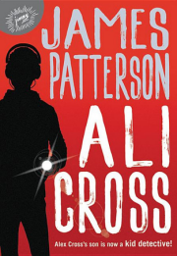
Ali Cross (#1)
by James Patterson
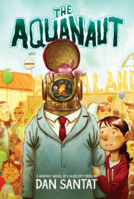
The Aquanaut
by Dan Santat
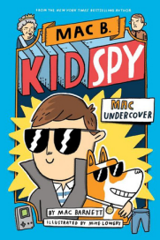
Mac Undercover
by Mac Barnett
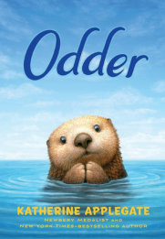
Odder
by Katherine Applegate
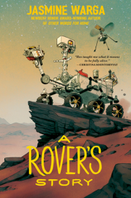
A Rover's Story
by Jasmine Warga
Stay
by Bobbie Pyron
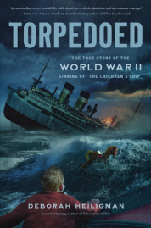
Torpedoed
by Deborah Heiligman
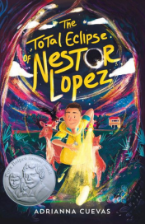
The Total Eclipse
of Nestor Lopez
by Adrianna Cuevas
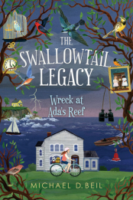
Wreck at Ada's Reef by Michael D. Biel
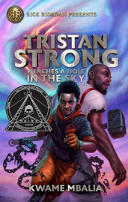
Tristan Strong Punches a Hole the Sky
by Kwame Mbalia
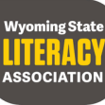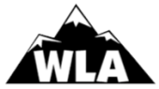https://www.wyla.org/Wyoming-Book-Awards

